Quantitative Data Plan

Research Components

Character Personality

Character personality ranking
  - Which character personality is ranked best?
    - E.g. 1 point for place 3. 2 points for place 2 and 3 points for place 1. The voice with most points is ranked best.
  - Which character personality is ranked number 1 the most?

Character personality traits
  - For each character personality, which are the 8 most chosen personality traits?
  - For each character personality, how do the 8 most chosen personality traits align with the originally pre-defined personality traits?

Spoken Voice

Speaking styles on a scale from 1-5
- How does each voice score for each “speaking style labeled trait”? Here you can find the speaking styles and traits: Speaking Style Traits Quantitative test design.docx

  - There are 4 speaking styles: Green, Blue, Orange, Red.
  - There are 16 traits distributed across the 4 speaking styles.

Individual evaluation scale (see if can be included)
- How does each voice score on a scale from 1-10?
- Based on how many participants is the 1-10 score based? (participants will not be asked to rate all 18 voices on a scale from 1-10. Only the 8 selected voices in the beginning of the test).

Voice ranking
  - Which 8 voices are chosen the most out of 18?
  - Which 3 voices are chosen the most out of 18?
  - Which voice is ranked best?
    - E.g. 1 point for place 3. 2 points for place 2 and 3 points for place 1. The voice with most points is ranked best.
  - Which voice is ranked number 1 the most?

Character Personality & Voice Combinations
- For character personality 1, which are the best 3 voices? And based on how many participants?
- For character personality 2, which are the best 3 voices? And based on how many participants?
- For character personality 3, which are the best 3 voices? And based on how many participants?
- For character personality 4, which are the best 3 voices? And based on how many participants?

Data Analysis

Pre-analysis
- Delete respondents who did the test way too fast or extremely slow.
- Delete straight liners; respondents who filled in 1 point at all scales, for example.

Level 1: Total Results

1.A Character personality ranking
  - Which character personality is ranked best?
    - E.g. 1 point for place 3. 2 points for place 2 and 3 points for place 1. The voice with most points is ranked best.
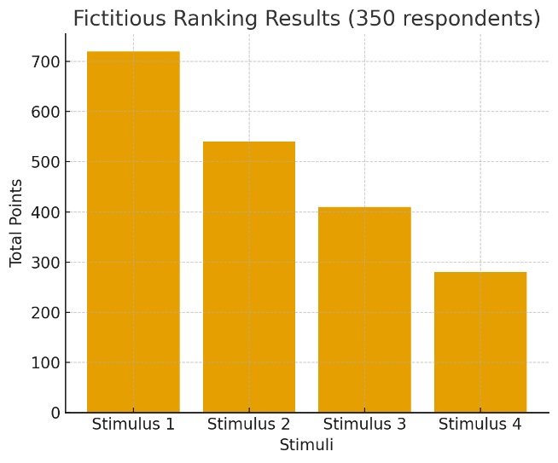
  - Which character personality is ranked number 1 the most?
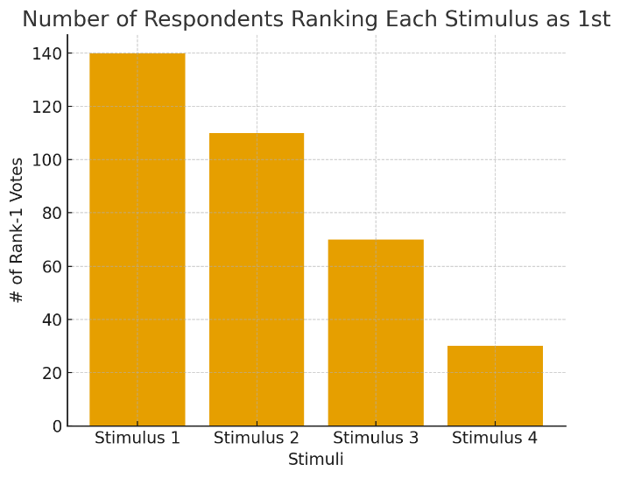

1.B Voice Ranking
  - Which 8 voices are chosen the most out of 18?
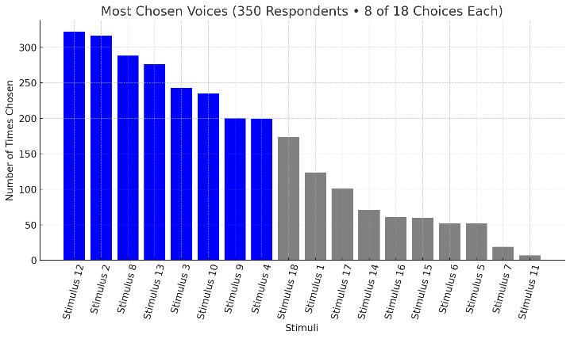
  - Which 3 voices are chosen the most out of 18? How many times does each voice end up in the top 3? ( this is based on the survey question where participants need to choose 3 out of the earlier selected 8 voices. So how often each of the 18 stimuli ended up in participants’ Top 3, after they first selected 8 out of 18.
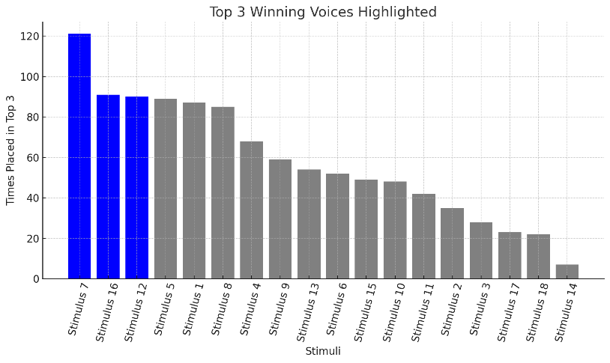

  - Which voice is ranked best in the ranking question for top 3.? (so not best 3 out of 8 question)
    - E.g. 1 point for place 3. 2 points for place 2 and 3 points for place 1. The voice with most points is ranked best.
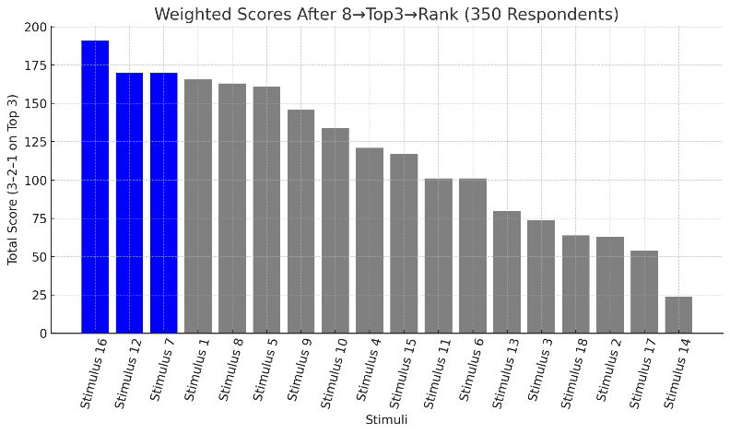

  - Which voice is ranked number 1 the most? (not always the voice with most points)
    - Each of the 350 participants gives exactly one 1st-place vote.
    - Total Rank-1 votes = 350.
    - Voices are sorted from most to least 1st-place votes.
    - The top 3 voices with the most Rank-1 votes are colored blue.
    - This can differ from the points-based winners (3–2–1 totals), because a voice may receive many 2nd/3rd places but fewer 1st places.
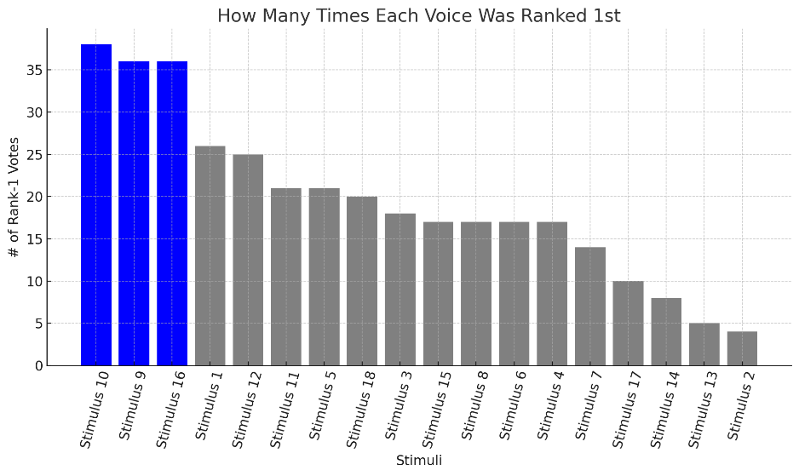

1.C Voice Speaking Styles – Perception Traits

- How does each voice score for each “speaking style labeled trait”? Here you can find the speaking styles and traits: Speaking Style Traits Quantitative test design.docx
A result diagram like this for every personality trait, so 16 in total:

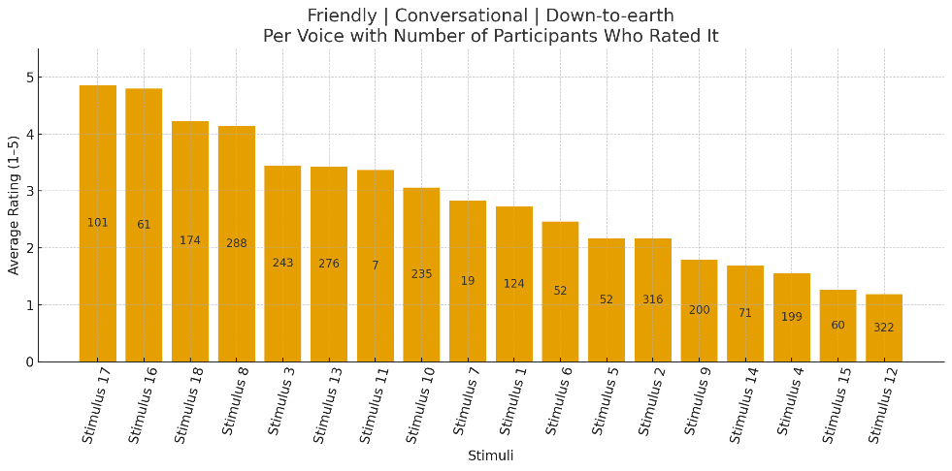

1.D Voice Scale 1-10 “how the voices are rated on a scale from 1-10”. (see if can be included)
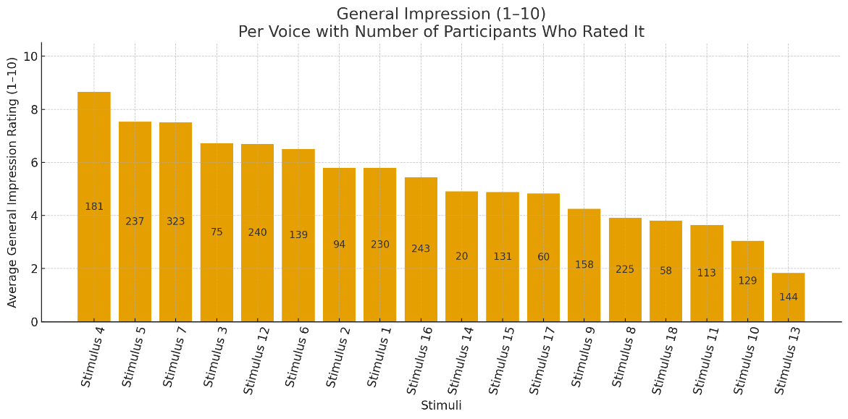

1.E Correlations Voice Speaking Styles // Voice Scale 1-10 (see if can be included)
Here you can find the speaking styles and traits: Speaking Style Traits Quantitative test design.docx The speaking styles are: Green, Blue, Orange and Red. Let’s show how scoring better on these speaking styles correlates (or not) with better Voice Scale 1-10 evaluation. For each speaking style we show how the traits in these speaking styles correlate with Voice Scale 1-10 evaluation. This gives us a total of 4 correlation diagrams. Example for speaking style green:
Trait 1: Friendly | Conversational | Down-to-earth
Trait 2: Approachable | Familiar | Warm
Trait 3: Optimistic | Benevolent | Positive | Appreciative
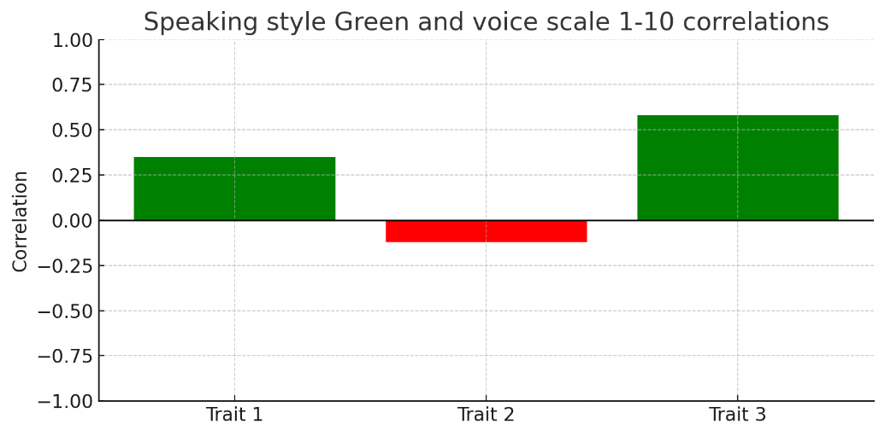

1.F Correlations Voice Speaking Styles // Voice Ranking Points
Here you can find the speaking styles and traits: Speaking Style Traits Quantitative test design.docx The speaking styles are: Green, Blue, Orange and Red. Let’s show how scoring better on these speaking styles correlates (or not) with better Vocie Ranking results. For each speaking style we show how the traits in these speaking styles correlate with voice ranking points. This gives us a total of 4 correlation diagrams. Example for speaking style green:
Trait 1: Friendly | Conversational | Down-to-earth
Trait 2: Approachable | Familiar | Warm
Trait 3: Optimistic | Benevolent | Positive | Appreciative
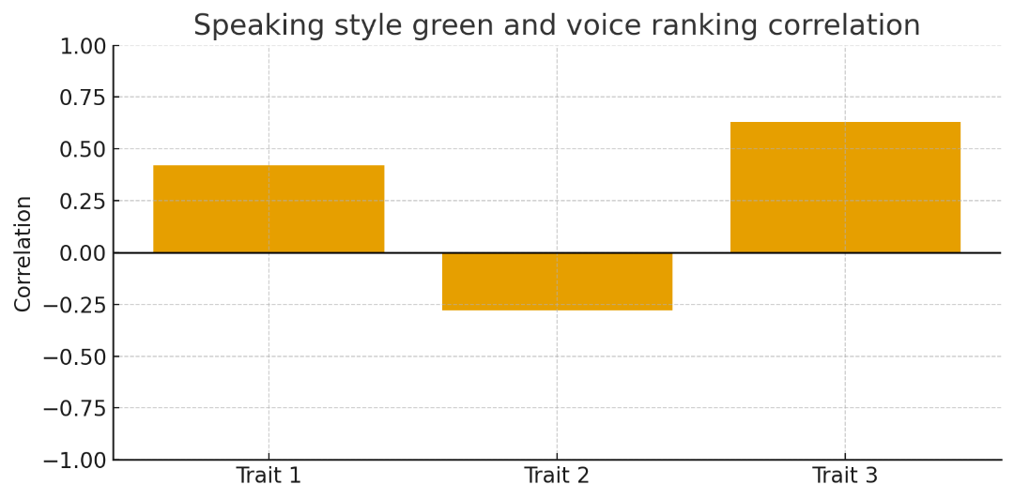

1.G Correlations Voice Speaking Styles // Voice Scale 1-10 (like 1.E) CONSIDERING FEMALE VOICES AND MALE VOICES SEPARATELY

This will results in:
- 4 correlation diagrams considering each speaking style (4) and all female voice results.
- 4 correlation diagrams considering each speaking style (4) and all male voice results.

1.H Correlations Voice Speaking Styles // Voice Ranking Points (like 1.F) CONSIDERING FEMALE VOICES AND MALE VOICES SEPARATELY
This will results in:
- 4 correlation diagrams considering each speaking style (4) and all female voice results.
- 4 correlation diagrams considering each speaking style (4) and all male voice results.

1.I Correlation Heatmap all evaluations // voice acoustic data. CONSIDERING FEMALE VOICES AND MALE VOICES SEPARATELY
This will results in two heatmaps like this. One for male voices and one for female voices.
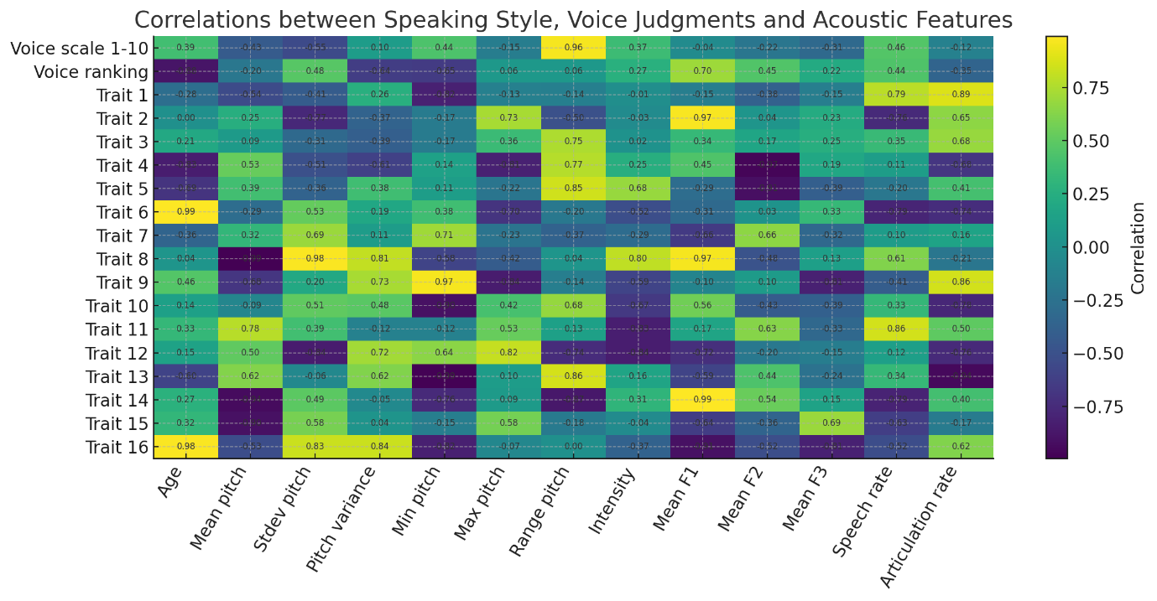

1.J Most prominent Character Personality Traits

The last question of the survey is about traits for the described character's personality. For each Character personality, we want to display the 8 most chosen character personality traits. This will give us a total of 4 diagrams, one for each character personality included in the test.
Eample results for character personality 1:
Blue: the predefined character personality traits. \

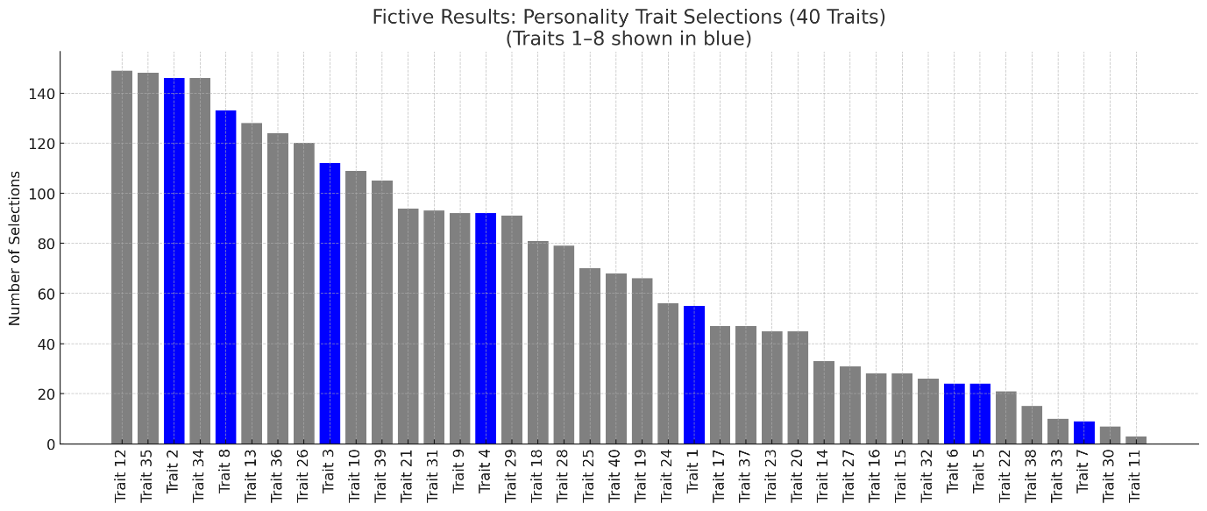

Level 2: Results Per Subgroup

- Results 1.A – 1.J for the subgroup “Female Respondents”.
- Results 1.A – 1.J for the subgroup “Male Respondents”.
- Results 1.A – 1.J for the subgroup “Age 20-29 Respondents”.
- Other results per subgroup depend on respondents distribution and data available. Possible subgroups include:
  - Customer segment-based
  - Ethnicity-based
  - Income-based
  - Living situation

